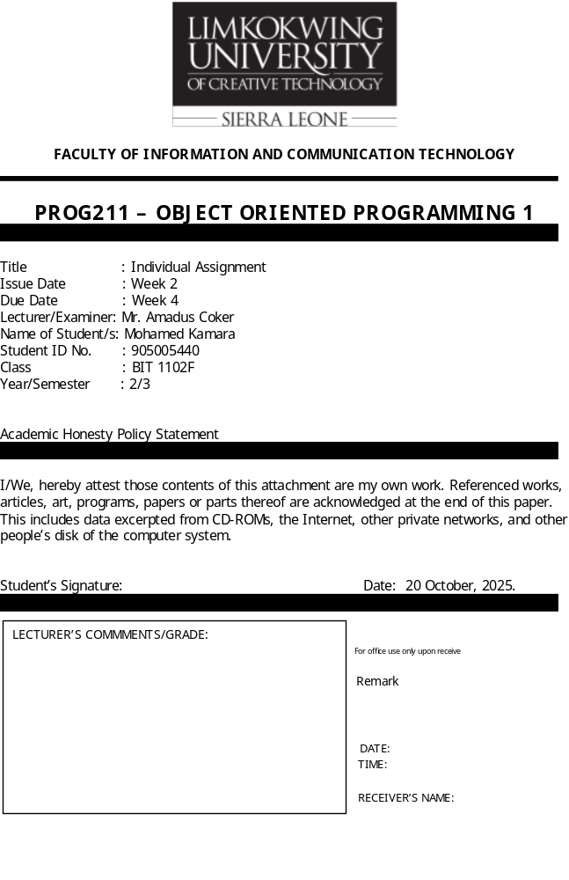
Design Rationale: Mini Library Management System (Python)
This document explains the design choices made for the Mini Library Management System developed for the Object-Oriented Programming 1 course. The system was built using Python and employs core data structures such as dictionaries, lists, and tuples to efficiently manage books, members, and library operations like adding, searching, updating, deleting, borrowing, and returning books.
1. Design Approach:
The system follows a procedural structure with well-defined functions that handle each major operation (CRUD and borrow/return). The design ensures modularity, where each function performs a single, clear task. This approach improves readability, debugging, and reusability of code while maintaining the integrity of stored data.
2. Data Structures Used:
a. Dictionary: The dictionary was chosen to store book details because it allows fast access, updates, and deletion using unique ISBN keys. Each book record contains fields such as title, author, genre, and total copies, making it easy to organize and retrieve data.
b. List of Dictionaries: A list was used to store member information. Each member record is represented as a dictionary containing the member ID, name, email, and borrowed books. The list structure allows flexible addition and iteration through members.
c. Tuple: The tuple was used to store valid book genres (e.g., Fiction, Non-Fiction, and Sci-Fi). Since genres are fixed and should not change during program execution, a tuple ensures data immutability and integrity.
3. Functional Design:
Each core operation was implemented as a standalone function to maintain simplicity and clarity. Functions like add_book(), search_books(), borrow_book(), and return_book() directly interact with the data structures, ensuring data consistency and preventing invalid actions (e.g., borrowing unavailable books or exceeding borrowing limits).
4. UML Design Summary
The UML diagram represents the logical relationship between key components: the Book and Member data structures, and the main operations that interact with them. It visually shows how each function manipulates or retrieves information from the system.
5. Conclusion
The combination of dictionaries, lists, and tuples provides a balanced approach to achieving flexibility, speed, and reliability in managing library operations. The system is modular, easy to extend, and well-suited for beginner-level Object-Oriented Programming projects.

5. How to Run
1. Make sure Python is installed (python --version).
2. Save all files in one folder:
operations.py
demo.py
tests.py
3. Run the demo:
Python demo.py
4. To test all features:
Python tests.py
If successful, you’ll see:
All tests passed successfully!

Operaton.py
books = {}
members = []
genres = ("Fiction", "Non-Fiction", "Sci-Fi")

def add_book(isbn, title, author, genre, total_copies):
if isbn in books:
return "Book already exists."
if genre not in genres:
return "Invalid genre."
books[isbn] = {"title": title, "author": author, "genre": genre, "total_copies": total_copies}
return "Book added successfully."

def add_member(member_id, name, email):
for member in members:
if member["member_id"] == member_id:
return "Member ID already exists."
members.append({"member_id": member_id, "name": name, "email": email, "borrowed_books": []})
return "Member added successfully."

def search_books(keyword):
results = [book for book in books.values() if keyword.lower() in book["title"].lower() or keyword.lower() in book["author"].lower()]
return results

def update_book(isbn, title=None, author=None, genre=None, total_copies=None):
if isbn not in books:
return "Book not found."
if genre and genre not in genres:
return "Invalid genre."
if title: books[isbn]["title"] = title
if author: books[isbn]["author"] = author
if genre: books[isbn]["genre"] = genre
if total_copies is not None: books[isbn]["total_copies"] = total_copies
return "Book updated successfully."

def delete_book(isbn):
if isbn not in books:
return "Book not found."
del books[isbn]
return "Book deleted successfully."

def borrow_book(member_id, isbn):
for member in members:
if member["member_id"] == member_id:
if isbn not in books:
return "Book not found."
if books[isbn]["total_copies"] <= 0:
return "No copies left."
if len(member["borrowed_books"]) >= 3:
return "Borrow limit reached (3 books)."
books[isbn]["total_copies"] -= 1
member["borrowed_books"].append(isbn)
return "Book borrowed successfully."
return "Member not found."

def return_book(member_id, isbn):
for member in members:
if member["member_id"] == member_id:
if isbn in member["borrowed_books"]:
member["borrowed_books"].remove(isbn)
books[isbn]["total_copies"] += 1
return "Book returned successfully."
return "This book was not borrowed by the member."
return "Member not found."

Demo.py
From Operations import *
print(add_book("978123", "Python Basics", "John Doe", "Non-Fiction", 5))
print(add_member("M001", "Alice", "alice@example.com"))
print(borrow_book("M001", "978123"))
print(return_book("M001", "978123"))
print(delete_book("978123"))

Test.py
From Operations import *
def run_tests():
assert add_book("001", "OOP", "Smith", "Fiction", 2) == "Book added successfully."
assert add_member("M001", "Alice", "alice@example.com") == "Member added successfully."
assert borrow_book("M001", "001") == "Book borrowed successfully."
assert borrow_book("M001", "001") == "Book borrowed successfully."
assert borrow_book("M001", "001") == "No copies left."
assert return_book("M001", "001") == "Book returned successfully."
assert delete_book("001") == "Book deleted successfully."
print("All tests passed successfully!")
if __name__ == "__main__":
run_tests()

Operation.py
books = {}
members = []
genres = ("Fiction", "Non-Fiction", "Sci-Fi")
def add_book(isbn, title, author, genre, total_copies):
if isbn in books:
return "Book already exists."
if genre not in genres:
return "Invalid genre."
books[isbn] = {"title": title, "author": author, "genre": genre, "total_copies": total_copies}
return "Book added successfully."
def add_member(member_id, name, email):
for member in members:
if member["member_id"] == member_id:
return "Member ID already exists."
members.append({"member_id": member_id, "name": name, "email": email, "borrowed_books": []})
return "Member added successfully."
def search_books(keyword):
results = [book for book in books.values() if keyword.lower() in book["title"].lower() or keyword.lower() in book["author"].lower()]
return results
def update_book(isbn, title=None, author=None, genre=None, total_copies=None):
if isbn not in books:
return "Book not found."
if genre and genre not in genres:
return "Invalid genre."
if title: books[isbn]["title"] = title
if author: books[isbn]["author"] = author
if genre: books[isbn]["genre"] = genre
if total_copies is not None: books[isbn]["total_copies"] = total_copies
return "Book updated successfully."
def delete_book(isbn):
if isbn not in books:
return "Book not found."
del books[isbn]
return "Book deleted successfully."
def borrow_book(member_id, isbn):
for member in members:
if member["member_id"] == member_id:
if isbn not in books:
return "Book not found."
if books[isbn]["total_copies"] <= 0:
return "No copies left."
if len(member["borrowed_books"]) >= 3:
return "Borrow limit reached (3 books)."
books[isbn]["total_copies"] -= 1
member["borrowed_books"].append(isbn)
return "Book borrowed successfully."
return "Member not found."
def return_book(member_id, isbn):
for member in members:
if member["member_id"] == member_id:
if isbn in member["borrowed_books"]:
member["borrowed_books"].remove(isbn)
books[isbn]["total_copies"] += 1
return "Book returned successfully."
return "This book was not borrowed by the member."
return "Member not found."

Demo.py
from Operations import *
print(add_book("978123", "Python Basics", "John Doe", "Non-Fiction", 5))
print(add_member("M001", "Alice", "alice@example.com"))
print(borrow_book("M001", "978123"))
print(return_book("M001", "978123"))
print(delete_book("978123"))
C:\Users\moham\PycharmProjects\PythonProject1\.venv\Scripts\python.exe C:\Users\moham\PycharmProjects\PythonProject1\Demo.py
Book added successfully.
Member added successfully.
Book borrowed successfully.
Book returned successfully.
Book deleted successfully.

Process finished with exit code 0
Test.py
from Operations import *
def run_tests():
assert add_book("001", "OOP", "Smith", "Fiction", 2) == "Book added successfully."
assert add_member("M001", "Alice", "alice@example.com") == "Member added successfully."
assert borrow_book("M001", "001") == "Book borrowed successfully."
assert borrow_book("M001", "001") == "Book borrowed successfully."
assert borrow_book("M001", "001") == "No copies left."
assert return_book("M001", "001") == "Book returned successfully."
assert delete_book("001") == "Book deleted successfully."
print("All tests passed successfully!")
if __name__ == "__main__":
run_tests()

C:\Users\moham\PycharmProjects\PythonProject1\.venv\Scripts\python.exe C:\Users\moham\PycharmProjects\PythonProject1\Test.py
All tests passed successfully!

Process finished with exit code 0

